Class: Final Year (Computer Science and Engineering)
Year: 2025-26 Semester: 1
Course: High Performance Computing Lab

Practical No. 4
Name: Jasmine Sayyad
Exam Seat No: 22510033
Batch: B-8
Title of practical:
Study and Implementation of Synchronization

Problem Statement 1:

Analyze and implement a Parallel code for below programs using OpenMP considering synchronization requirements. (Demonstrate the use of different clauses and constructs wherever applicable)

Fibonacci Computation:

Screenshots:
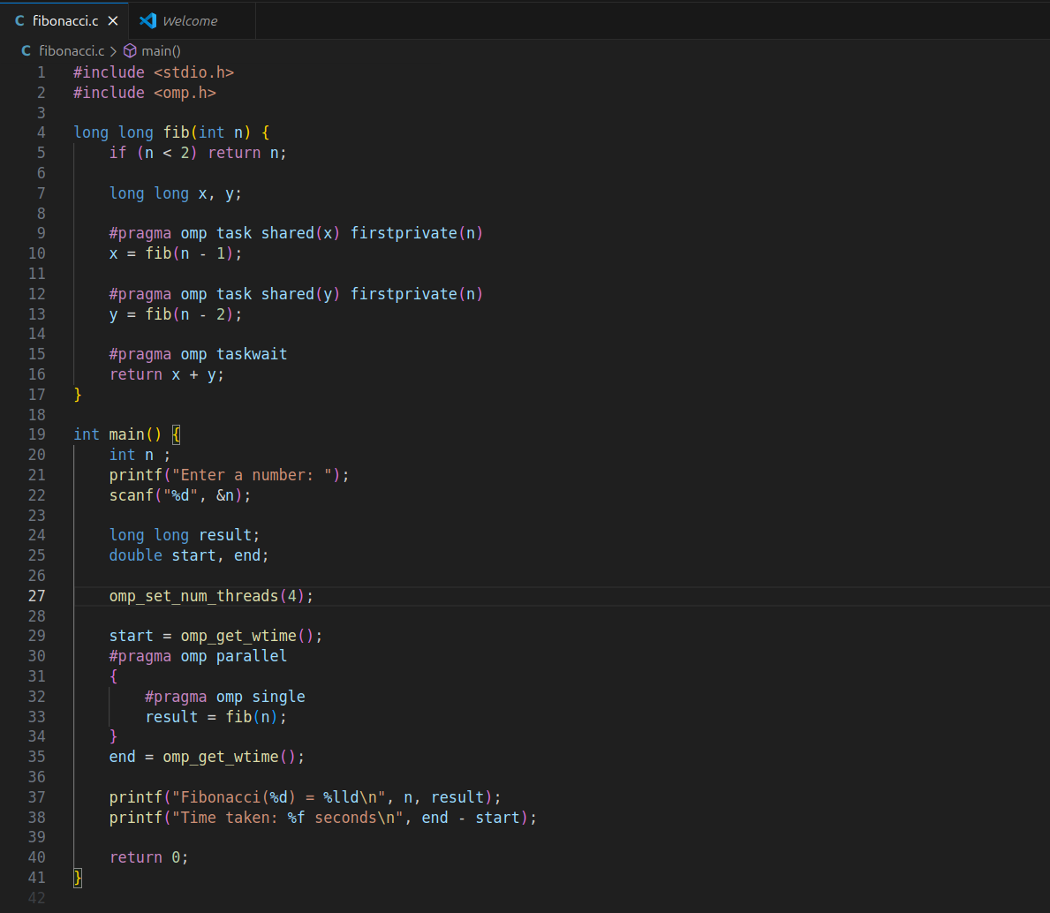
OutPut:
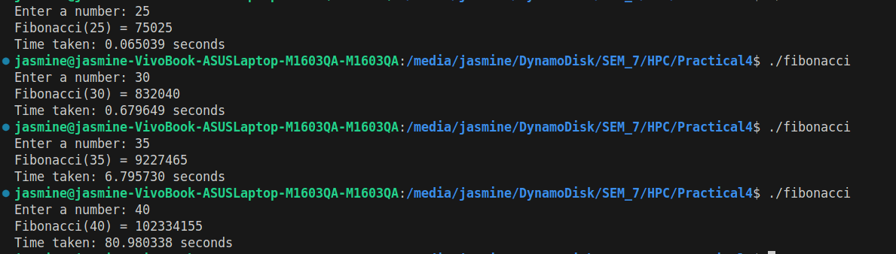

Information:

#pragma omp single

Ensures only one thread in the team starts the fib(n) call.
Other threads wait for tasks to appear and help execute them

#pragma omp task
Creates an independent unit of work that can be executed by any available thread.
shared(x) → All threads see the same x variable (final result will be stored there).
firstprivate(n) → Each task gets its own private copy of n with the current value from the calling function.

#pragma omp taskwait
Ensures both tasks finish before continuing.
Without it, the function could return before x and y are computed.

Problem Statement 2:

Analyze and implement a Parallel code for below programs using OpenMP considering synchronization requirements. (Demonstrate the use of different clauses and constructs wherever applicable)

Producer Consumer Problem

Screenshots:
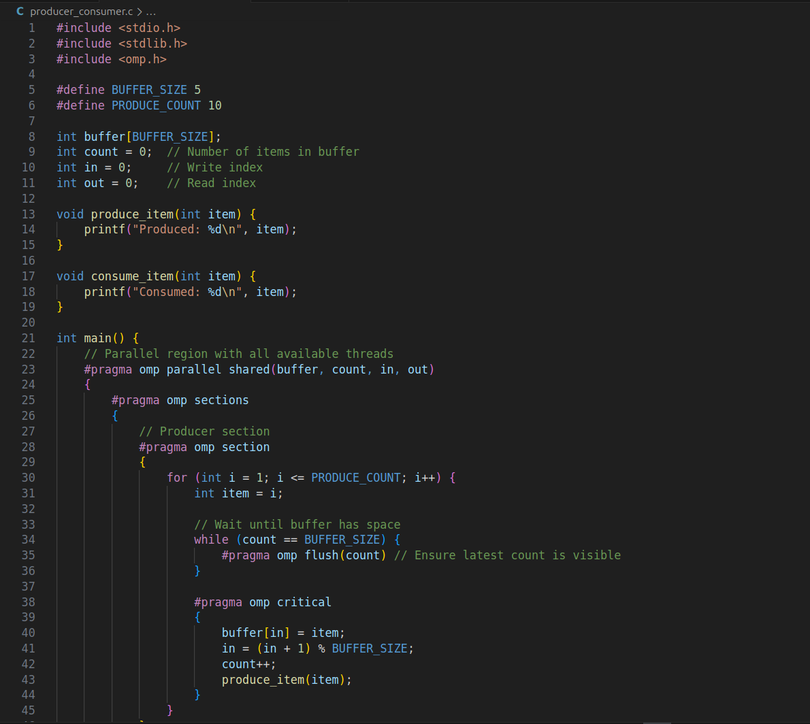
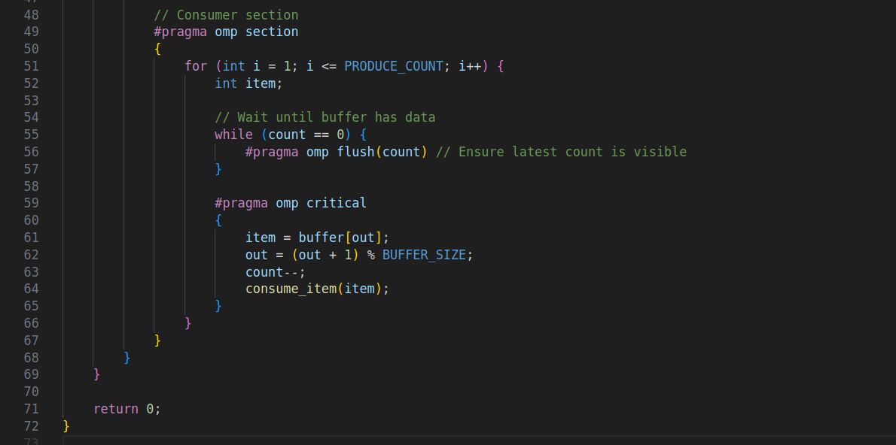

Output:
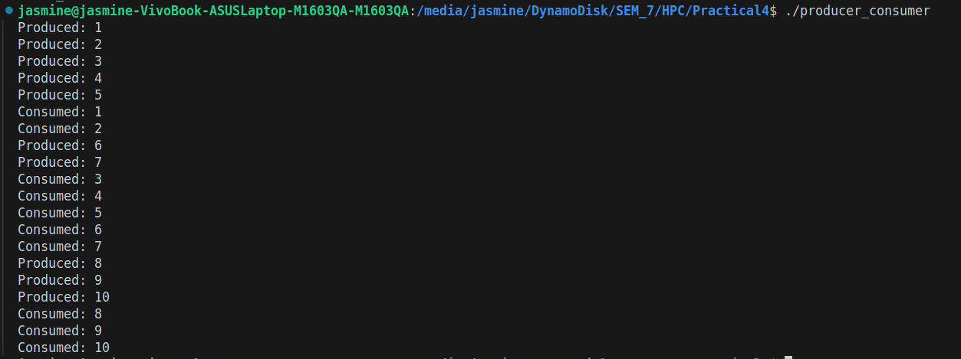

Information:
parallel → create a team of threads.
sections / section → split producer and consumer.
critical → prevent race conditions.
flush → ensure memory visibility between threads.
shared → share buffer, counters, and indices across threads.

Github Link:

https://github.com/av-nandedkar/HPC

